Midterm
Bradley Johnson
Kaire Campomanes
ITAI 437
Professor Patricia McManus
25 March 2026

System Profile for Chatbots and Assistants
For this project, Kaire and I selected chatbots and AI assistants as the primary category for analysis, with my individual focus centered on evaluating ChatGPT. This category was chosen due to its high level of accessibility and the frequency with which users encounter these systems in everyday life. Unlike more specialized AI tools that require technical expertise or limited access, chatbots are widely available and easy to interact with, making them an ideal candidate for repeated, hands-on experimentation. In recent years, chatbots have become increasingly integrated into both personal and professional contexts. Students use them to support learning and writing tasks, businesses rely on them for customer interaction, and individuals use them for general information and problem-solving. Because of this widespread adoption, chatbots provide a practical and relevant opportunity to evaluate how modern AI systems compare to human cognitive processes. Systems such as ChatGPT are particularly useful for this type of analysis because they simulate conversation, reasoning, and information retrieval functions that closely relate to how the human brain processes and communicates information.
Another important factor in selecting a chatbot for this audit is the ability to conduct controlled and repeatable experiments. The system responds quickly and consistently to user input, allowing for multiple test scenarios to be performed in a short period of time. This makes it possible to directly apply concepts from the course—such as attention, memory, and processing structure and observe how the AI behaves under different conditions. In addition, chatbot interactions are easy to document through saved conversations and screenshots, which provides clear evidence to support analysis and conclusions.
The transparency of chatbot responses also strengthens their suitability for evaluation. Unlike background AI systems that operate without direct user visibility, chatbots produce outputs that can be examined, compared, and critiqued in detail. This allows for a more structured and evidence-based approach when assessing how closely the system reflects known principles of brain function. For these reasons, chatbots—and specifically ChatGPT serve as an effective platform for conducting a neuroscience-based audit of artificial intelligence.

Experiment 1: Module 02 Brain Architecture
The purpose of this experiment was to evaluate how well ChatGPT reflects the concept of brain architecture, with a specific focus on the distinction between parallel and sequential processing. In the human brain, parallel processing allows multiple streams of information to be handled at the same time, enabling individuals to integrate sensory input, memory, and decision-making simultaneously. In contrast, many artificial intelligence systems are believed to rely more heavily on sequential processing, where tasks are completed step by step rather than all at once.
To investigate this difference, I designed a series of prompts intended to test how the system handles multiple instructions within a single interaction. The first test focused on a structured, multi-part request. The system was asked to explain how a car engine works, summarize that explanation in one sentence, and provide a real-world analogy. The response successfully addressed all components of the prompt, indicating that the AI can manage compound instructions within a single output. However, the structure of the response suggested that each part of the task was completed in sequence rather than simultaneously.
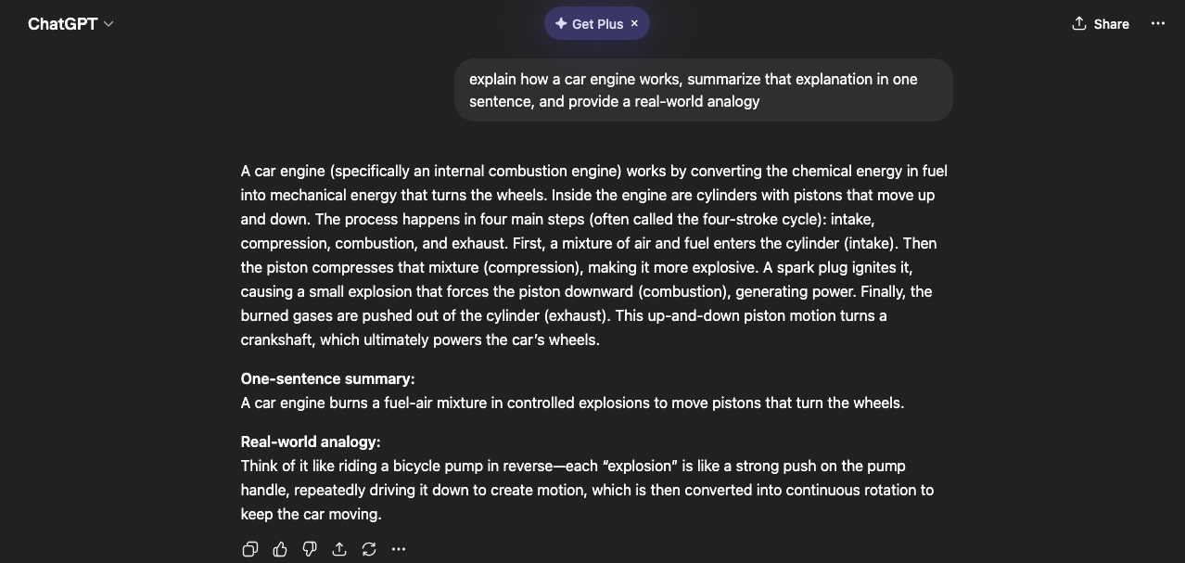
Building on this, a second test introduced a higher level of complexity by combining unrelated tasks into one prompt. The system was asked to write a short story, solve a mathematical problem, and explain a scientific concept. While the AI again completed all requested tasks accurately, the output was clearly divided into separate sections. This organization provided further evidence that the system processes each instruction individually, moving from one task to the next in a linear fashion rather than integrating them in parallel.
A final test was designed to more closely simulate the demands of parallel processing by requiring the system to manage multiple constraints at once. The AI was instructed to explain photosynthesis, compare it to cellular respiration, and remain within a strict word limit. In this case, the system showed some difficulty balancing all requirements equally. Although the explanation remained generally accurate, certain aspects such as the depth of comparison or adherence to the word limit were less consistent. This suggests that when task demands increase, the system prioritizes specific elements rather than fully integrating all aspects of the request at the same time.
Overall, the results of these experiments indicate that while ChatGPT can simulate behaviors that resemble parallel processing, its underlying approach appears to be sequential. The system effectively handles multiple instructions by breaking them into smaller components and addressing them one at a time. This differs from the human brain, which is capable of dynamically integrating multiple processes simultaneously. These findings highlight a key distinction between artificial and biological systems and suggest that current AI models approximate, rather than replicate, the parallel architecture of the brain.

